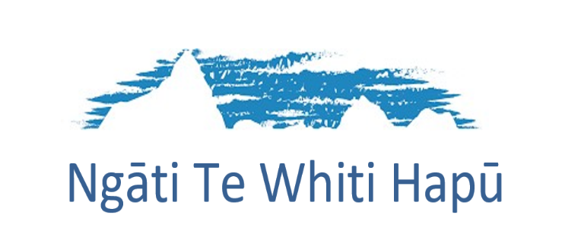
Annual General Meeting
For the year ended 30 June 2021
To be held on Sunday 1st May 2022
At 10am,
Port Office, Bayly Road, NEW PLYMOUTH

AGENDA:
- Karakia
- Apologies
- Minutes of previous AGM
- Matters Arising
- Interim-Chairperson’s Report
- Financial Audit Report 2020 – 2021
- Appointment of Chartered Accountants and Auditor
- Election of New Board x2
- Alterations to constitution:
- Article 18 Registered Offices.- Change from 97 Gill Street, New Plymouth to 131 South Road, New Plymouth 4310.
- Under Registrations 5.4 All new membership applications and review of member registration must be approved by Ngati Te Whiti nominated Whakapapa Committee.
- Add electronic meetings e.g., Zoom to the Constitution for Ngāti te Whiti Board Meetings and Hapū Meeting
- General Business
- Closing Karakia

